Session 1 July 8 - 12

SESSION DATES
Session 2 July 22 - 26
Session 3 August 5 – 9
Session 4 August 12 - 16

SUMMER GOLF CAMPS
This season we will be offering 4 weekly sessions with dates listed about. Each week of camps will be limited to 16 golfers, and all camps offered will be half-day camps, starting at 8:30am to 12:30pm.

The great news is that all of the things that made our golf camp program successful and fun continue – great instruction from our PGA of Canada professionals, incredible camp counsellors to ensure fun and safety, hot dog Fridays, and a Puma or adidas camp shirt and FootJoy glove for all participants.

We look forward to having your junior golfer join us for a fun camp experience.

SUMMER
GOLF CAMPS

Norman Rogers Airport -
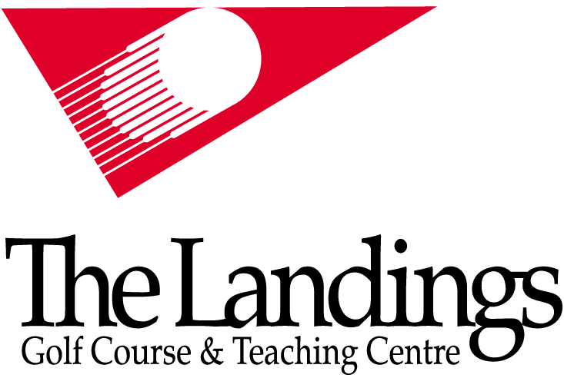
Front Road (1 km West of Bayridge Drive)

Register on-line at
www.thelandings.ca
or by phone at
(613) 634-7888

HALF-DAY GOLF CAMP
The Landings Golf Course offers a half-day morning Golf camp, which includes three hours of instruction from PGA of Canada professional staff at our practice facility. Under the direction of Landings Head Professional Chris Barber, the golf camp is a great opportunity to introduce children aged 8 to 13 to the sport of golf.
WHAT DO THE CHILDREN DO?
In a typical day, campers will spend the morning on our practice range and putting green. On selected days, the campers will head out onto the golf course to play a few holes. This puts into practice what they have learned and allows us to address rules, etiquette and on-course play.
DROP OFF AND PICK UP TIMES
Campers are to be dropped off and picked up at the Golf Course Clubhouse so they can be signed in and out. The camp begins at 8:30 am and finishes at 12:30pm. Supervision is available as of 8:15am and campers must be picked up by 12:45pm.
WHAT SHOULD YOU BRING?
Campers are welcome to bring their own golf clubs, but we have lots available for those who prefer to leave theirs at home or don’t have any. Bring along some snacks or check out our snack bar at the Clubhouse. Sunscreen, rain gear, and golf gloves are also recommended. Golf gloves will be provided as part of the camp program.

HOW MUCH DOES IT COST?
The camp costs $280.00 per week, plus 13% HST. This includes a camp golf shirt, a golf glove and a BBQ lunch on Friday for all campers.

